**Appendix D**

The associated manuscript involves a Delphi Study to identify empirical challenges and countermeasures, along with evaluating their relevance and effectiveness respectively. This appendix reports information on the conducted Delphi Study. Specifically, Table D1 reports information related to the practitioners involved in the Delphi Study. Only practitioners with at least five years of experience in ML for PdM were considered. For each practitioner, the years of experience, the country, the industrial plant, and the role within the organisation are listed in Table D1.

**Table D1**: Summary of the panel of practitioners selected for the Delphi Study.

|  |  |  |  |  |  |  |  |
| --- | --- | --- | --- | --- | --- | --- | --- |
| **Expert ID** |  | **Years of Experience** |  | **Country** |  | **Industrial plant** | **Role** |
| 1 |  | 11 |  | United Kingdom |  | Oil & Gas | Asset Manager |
| 2 |  | 5 |  | Italy |  | Manufacturing | Maintenance planner/scheduler |
| 3 |  | 20 |  | United Kingdom |  | Manufacturing | Maintenance supervisor |
| 4 |  | 35 |  | Germany |  | Chemical | Head of Maintenance Engineering |
| 5 |  | 6 |  | United States |  | Nuclear | Maintenance planner/scheduler |
| 6 |  | 9 |  | France |  | Aviation | Maintenance planner/scheduler |
| 7 |  | 5 |  | Japan |  | Oil & Gas | Maintenance planner/scheduler |
| 8 |  | 17 |  | Germany |  | Marine | Asset Manager |
| 9 |  | 10 |  | Italy |  | Electrical | Maintenance planner/scheduler |
| 10 |  | 7 |  | United States |  | Oil & Gas | Asset Manager |
| 11 |  | 7 |  | Italy |  | Electrical | Maintenance planner/scheduler |
| 12 |  | 12 |  | United Kingdom |  | Aviation | Maintenance supervisor |
| 13 |  | 6 |  | United States |  | Nuclear | Maintenance planner/scheduler |
| 14 |  | 7 |  | Germany |  | Pharmaceutical | Maintenance planner/scheduler |
| 15 |  | 11 |  | United Kingdom |  | Manufacturing | Maintenance planner/scheduler |
| 16 |  | 5 |  | United Kingdom |  | Aviation | Predictive Maintenance Specialist |
| 17 |  | 13 |  | United States |  | Electrical | Maintenance supervisor |
| 18 |  | 8 |  | France |  | Manufacturing | Asset manager |
| 19 |  | 9 |  | Japan |  | Chemical | Asset manager |

The conducted Delphi Study is composed of four rounds, among which the first is a preliminary round referred as “Round 0”. During “Round 0”, practitioners were asked to identify challenges pertaining to the adoption of ML for PdM. These challenges were integrated with the ones coming from literature and a questionnaire for the Delphi Study was created. After the validation of the questionnaire, the three remaining Delphi Study rounds were devoted to identifying the relevance of each challenge. In Round 1, practitioners were also asked to propose potential countermeasures for each challenge. The effectiveness of the proposed countermeasured was evaluated during Round 2 and Round 3 of the Delphi Study, along with the challenges that did not reach consensus. A summary of the conducted Delphi Study, with the number of challenges and countermeasures that reached consensus for each round is shown in Figure D1.

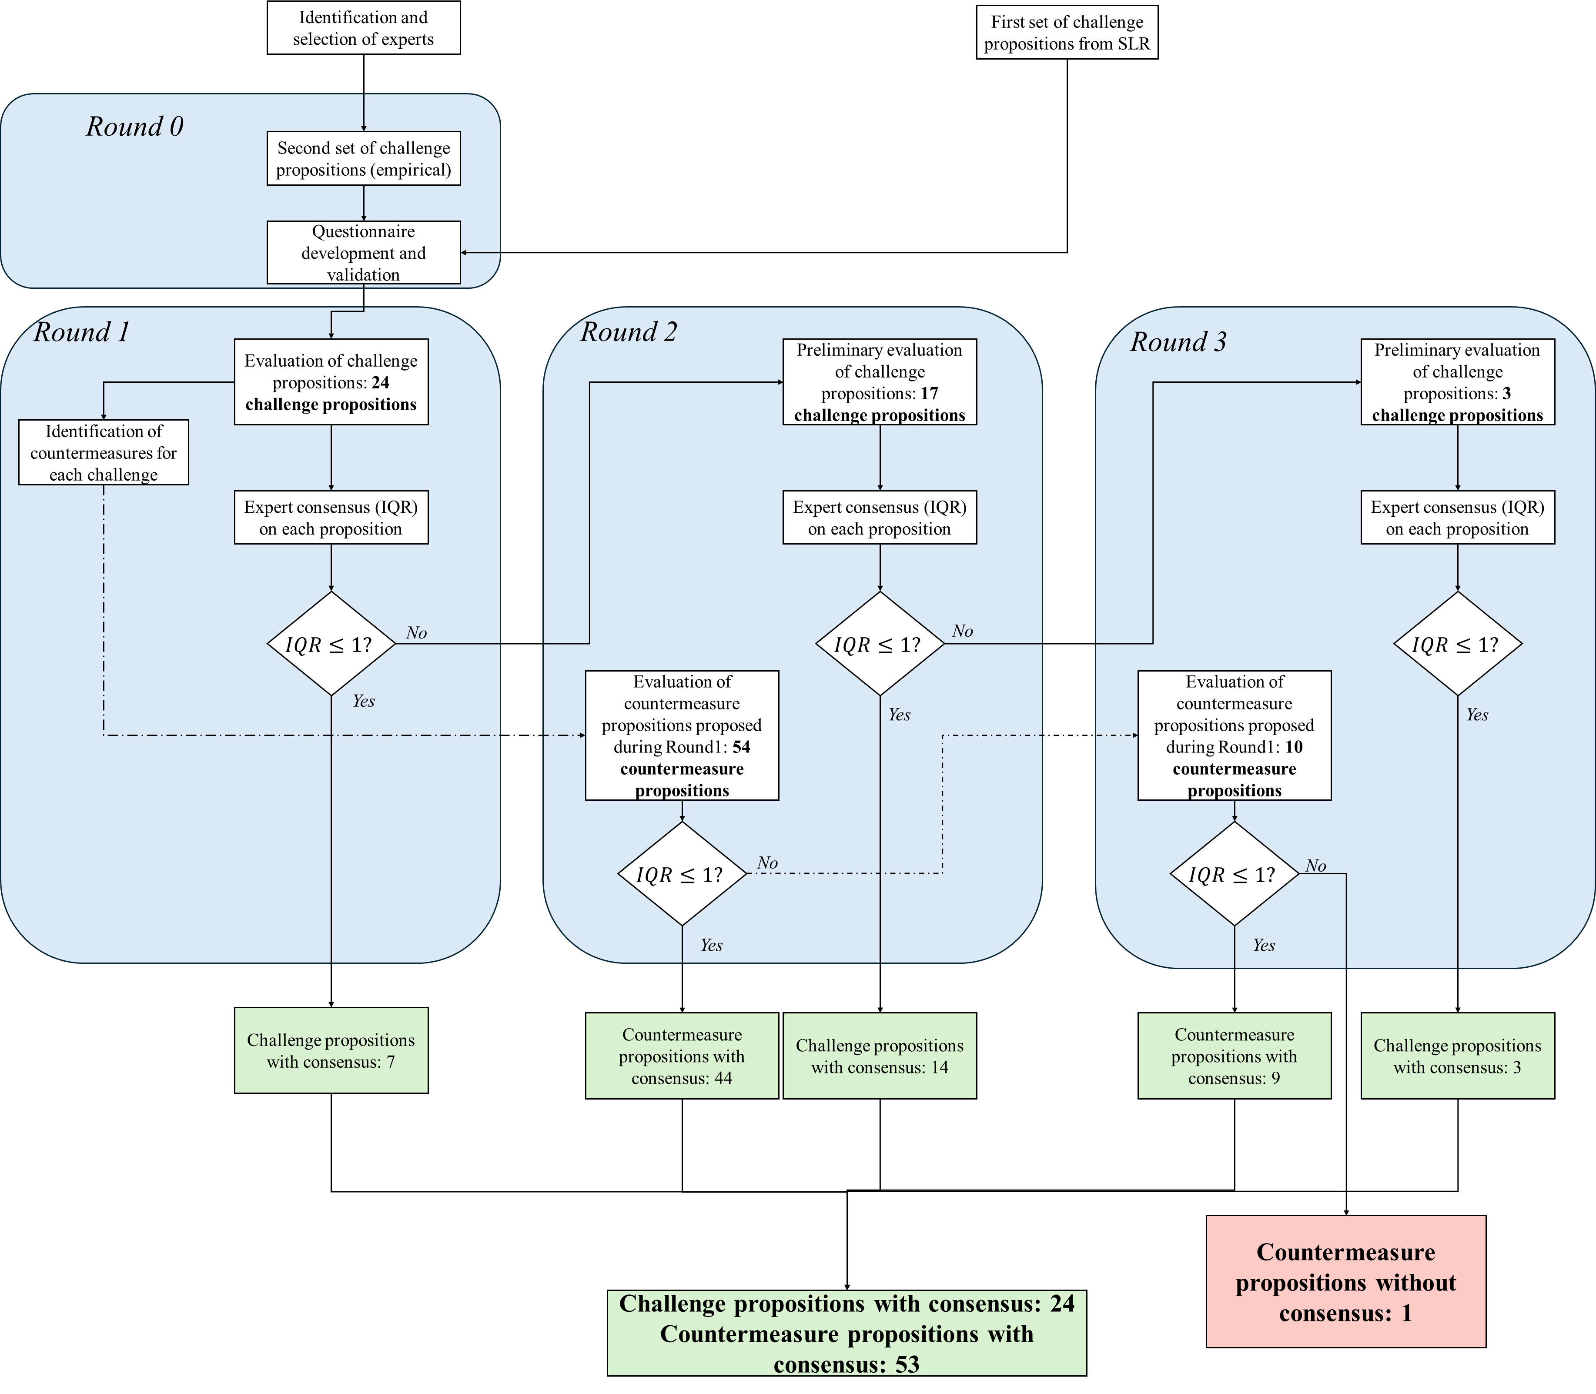

**Figure D1**: Flowchart of the overall process and the Delphi Study rounds